**FUNCTIONAL AND TECHNICAL COMBINED DOCUMENTATION**

**Page (7): My Portfolio (Front End Url:** http://localhost:8100/page7/Page7)

**Functional Picture:**

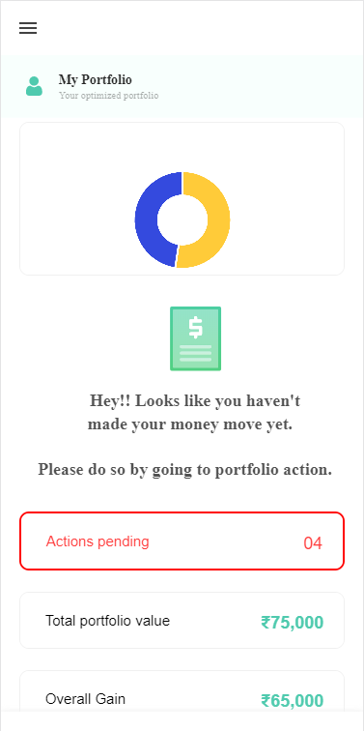

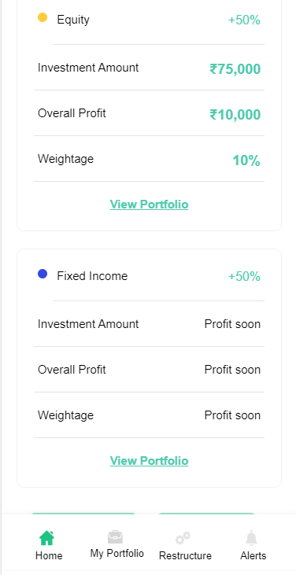

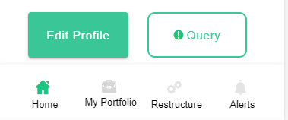

**In this Page, the user is going to see the overall portfolio performance consisting of stocks and fixed income products.**

**Technical Explanation (Front End and Back End):**

**In Page7.tsx, we are calling following 1 API:**

1. MarketCapWiseDiversificationAPI

: see backend python file. In this we are doing GET requests. We are using this to generate the data for the pie chart.

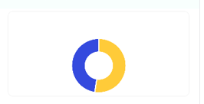

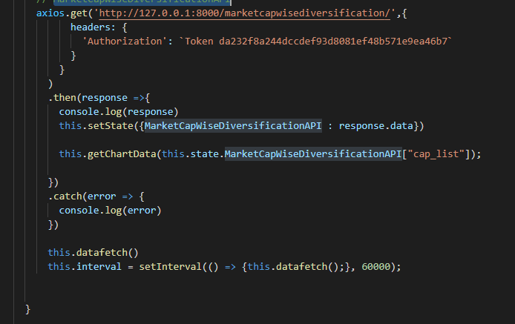

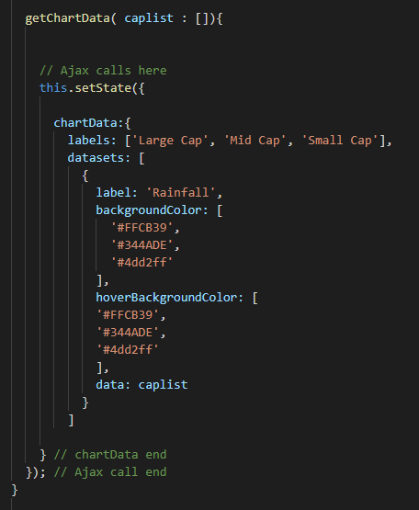

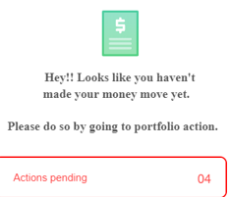

**For the above given alert message, we are checking if there is any pending actions in Portfolio Action section or not. If some actions are pending then we are telling the user to go Portfolio Action section. Please see the below given code for this.**

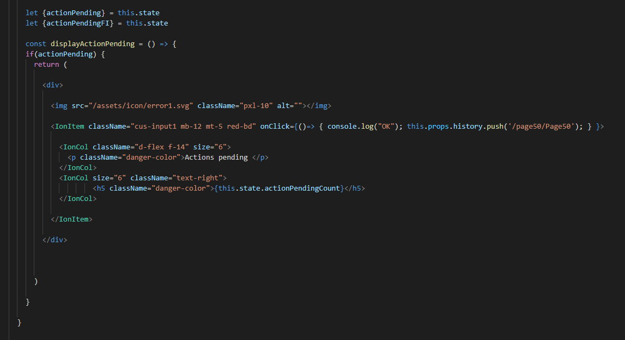

**Now, for displaying the portfolio performance we are calling the below url**

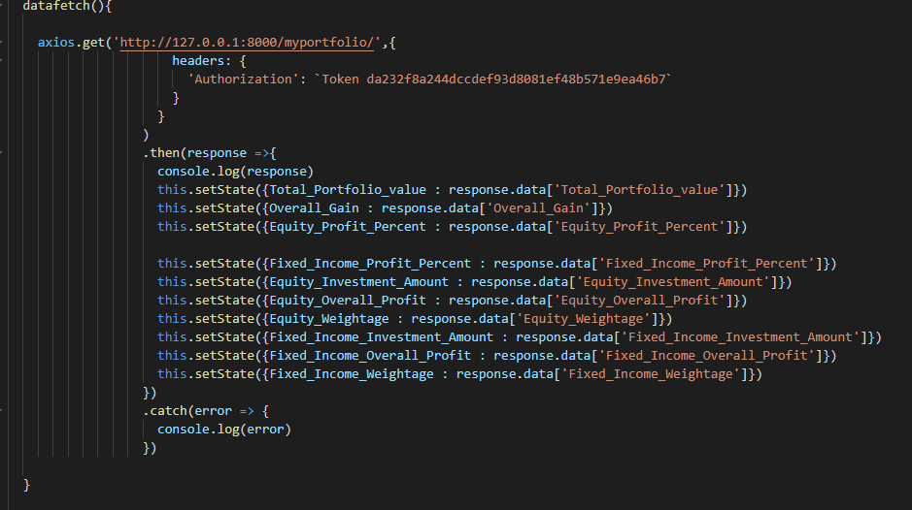

**which is further calling the** MyPortfolioAPI.

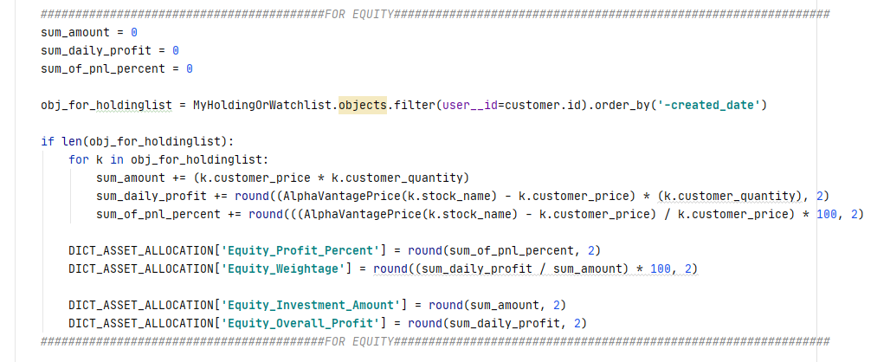

The above code is calculating the overall performance of Equity.

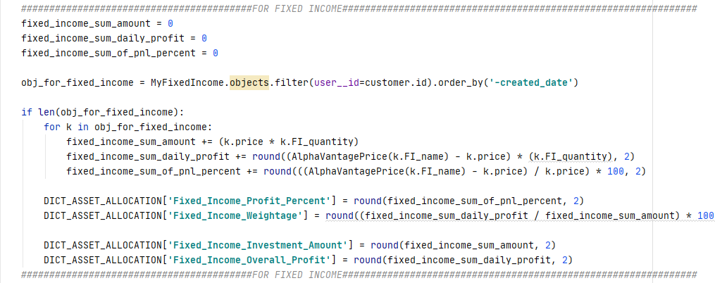

The above code is calculating the overall performance of Fixed Income.

DONE !!!